安装

windows

linux

lib导入

前置条件

1、3节点集群，每个节点的磁盘空间大于8G（journal 目前最小是8G）

2、

其他说明：

1、node1启用RRS， 所以涉及到GW 的启停，在node2上操作，因为启用RRS的node需要先停RRS 再停GW

2、node1启用RRS

遇到的问题

1、SSL认证

下图是win7 上执行testcase时，出现的SSL认证问题

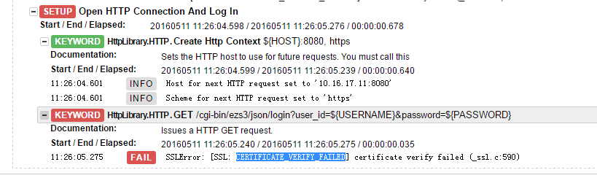

解决方法：

修改C:\Python27\Lib\site-packages\HttpLibrary目录下 __init__.py文件，增加如下记录，全局取消证书验证：

import ssl

ssl._create_default_https_context = ssl._create_unverified_context

问题2、 Wait Until Keyword Succeeds 出现CannotSendRequest

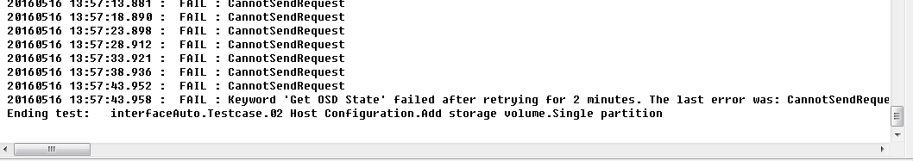

20160516 13:55:43.636 : INFO : ${osd_state} = OFFLINE

20160516 13:55:43.637 : INFO :

Argument types are:

<type 'str'>

<type 'unicode'>

20160516 13:55:43.637 : FAIL : OFFLINE != ONLINE

20160516 13:55:48.649 : FAIL : BadStatusLine: ''

20160516 13:55:53.656 : FAIL : CannotSendRequest

20160516 13:55:58.674 : FAIL : CannotSendRequest

20160516 13:56:03.679 : FAIL : CannotSendRequest

20160516 13:56:08.685 : FAIL : CannotSendRequest

20160516 13:56:13.695 : FAIL : CannotSendRequest

20160516 13:56:18.704 : FAIL : CannotSendRequest

20160516 13:56:23.718 : FAIL : CannotSendRequest

20160516 13:56:28.726 : FAIL : CannotSendRequest

20160516 13:56:33.742 : FAIL : CannotSendRequest

20160516 13:56:38.762 : FAIL : CannotSendRequest

20160516 13:56:43.780 : FAIL : CannotSendRequest

20160516 13:56:48.799 : FAIL : CannotSendRequest

20160516 13:56:53.817 : FAIL : CannotSendRequest

20160516 13:56:58.836 : FAIL : CannotSendRequest

20160516 13:57:03.852 : FAIL : CannotSendRequest

20160516 13:57:08.867 : FAIL : CannotSendRequest

20160516 13:57:13.881 : FAIL : CannotSendRequest

20160516 13:57:18.890 : FAIL : CannotSendRequest

20160516 13:57:23.898 : FAIL : CannotSendRequest

20160516 13:57:28.912 : FAIL : CannotSendRequest

20160516 13:57:33.921 : FAIL : CannotSendRequest

20160516 13:57:38.936 : FAIL : CannotSendRequest

20160516 13:57:43.952 : FAIL : CannotSendRequest

20160516 13:57:43.958 : FAIL : Keyword 'Get OSD State' failed after retrying for 2 minutes. The last error was: CannotSendRequest

Ending test: interfaceAuto.Testcase.02 Host Configuration.Add storage volume.Single partition

解决方法：

root@host1:/# vi /etc/apache2/apache2.conf

将KeepAliveTimeout 5调整为KeepAliveTimeout 100，单位是秒。

然后重启apache2服务.